***PROJECT REPORT TEMPLATE***

***1. INTRODUCTION:***

***1.1 Overview***

* + Marketing can conventionally be understood as a process of moving goods from producer to consumer with emphasis on sales and promotion.
  + A Wholesale distributor operating in different region has information on annual spending of several items in their stores across different regions and channels. Based on the different items on which the consumer spend annual we’ll evaluated the total spending on various items through which channel and in which region.

***1.2*** ***Purpose***

* + A description of the purpose of an organization’s marketing content. It explains the primary goal marketers have in distributing content.
  + One goal of this project is to best describe the variation in the different types of customers that a wholesale distributor interacts with them.

***2. PROBLEM DEFINITION & DESIGN THINKING:***

***2.1 Empathy Map***

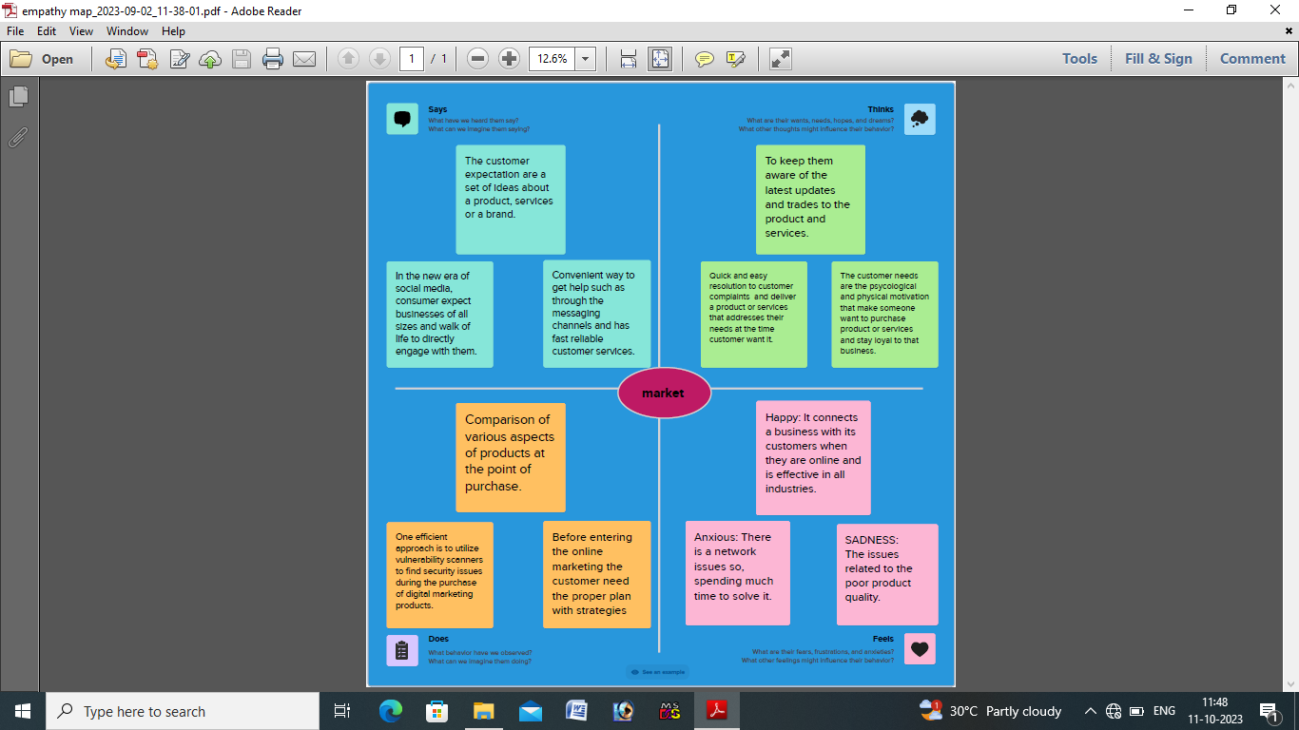

***2.2*** ***Ideation & Brainstorming Map***

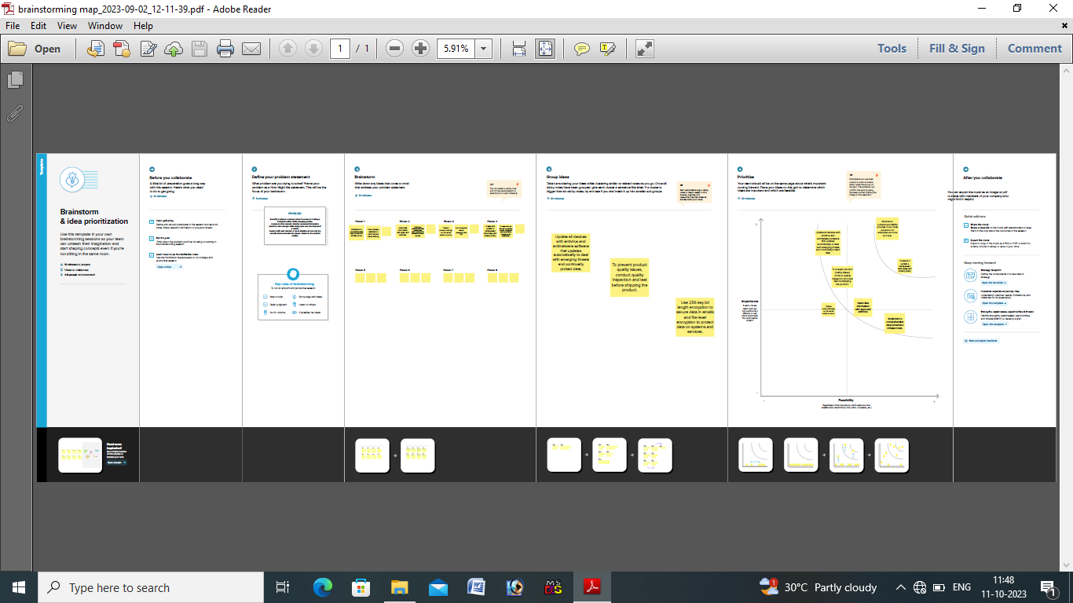

***3 RESULT:***

***3.1***

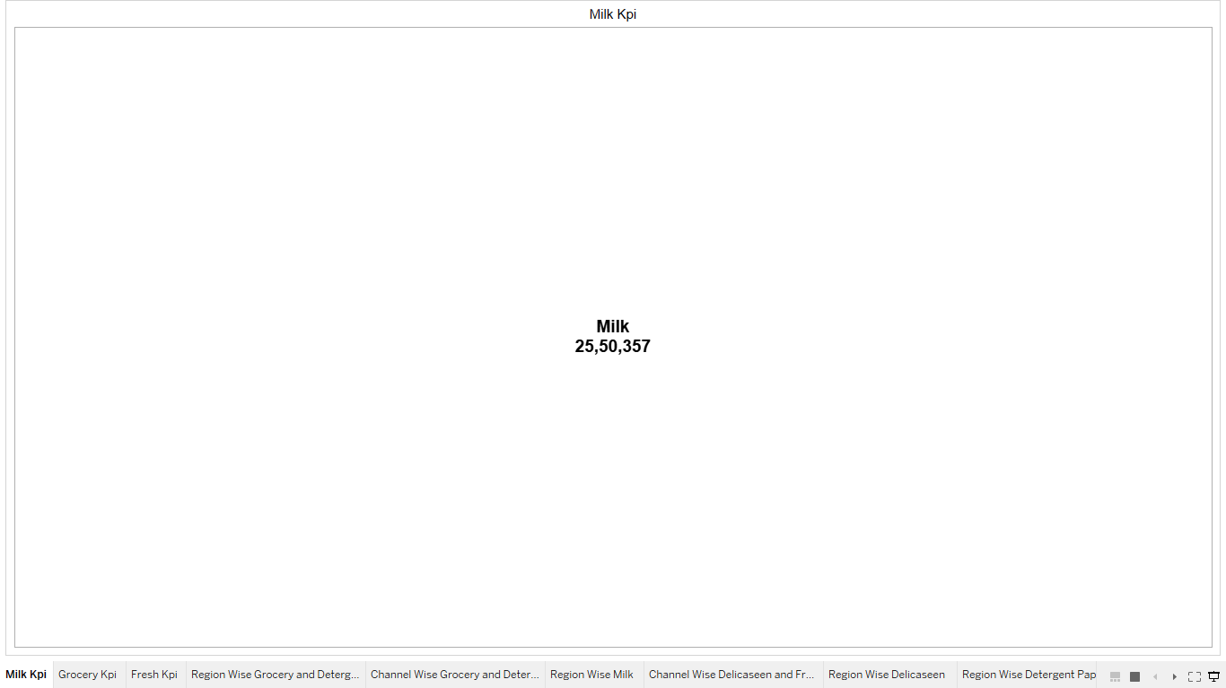

***3.2***

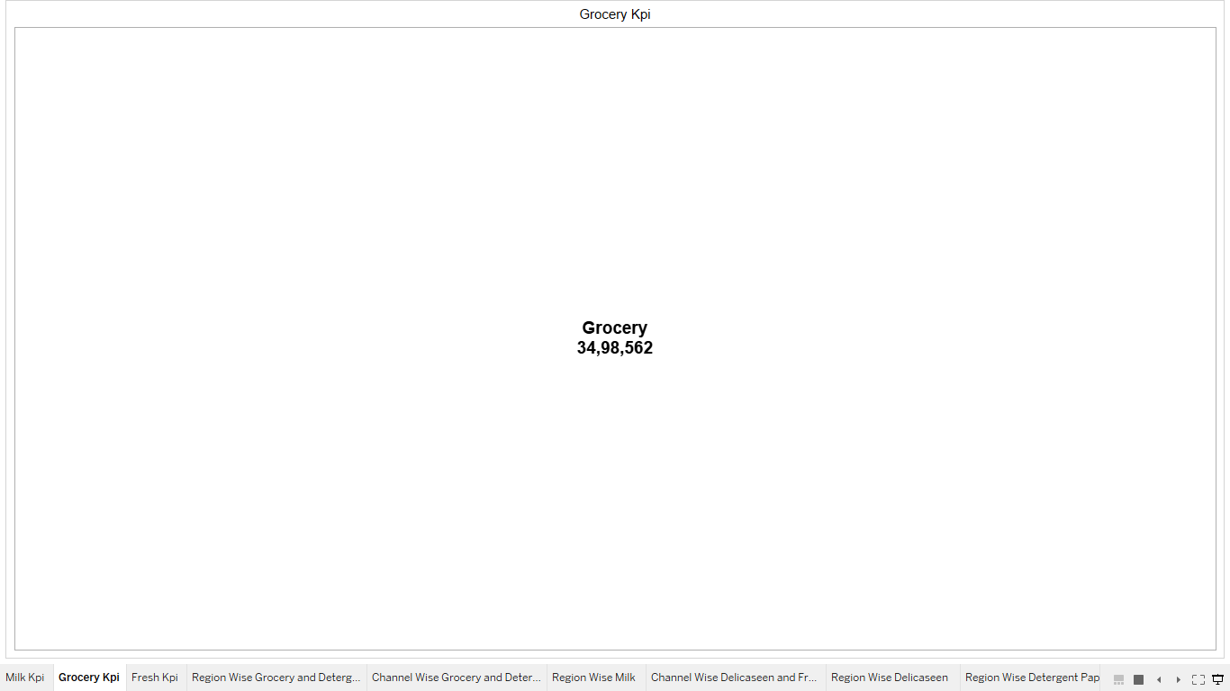

***3.3***

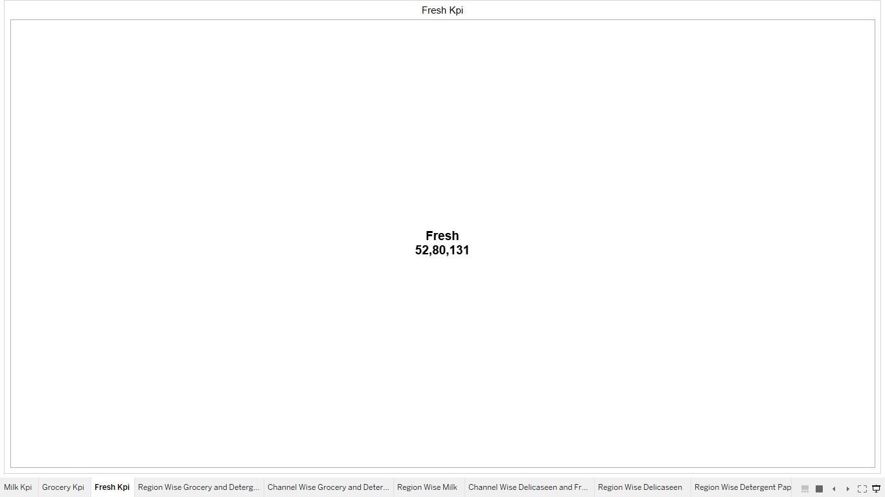

***3.4***

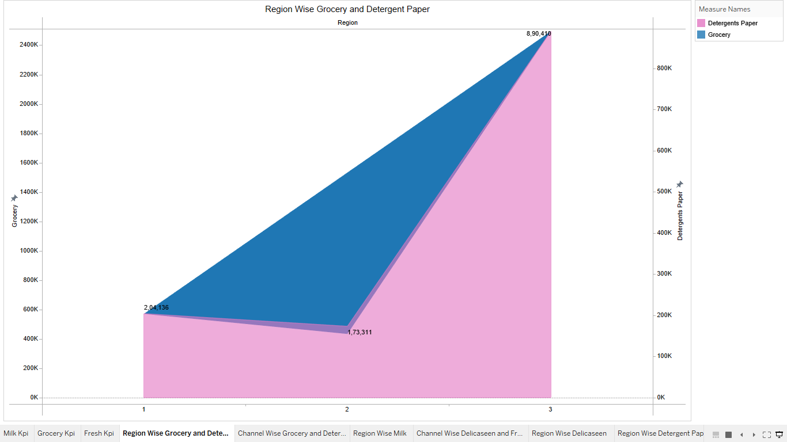

***3.5***

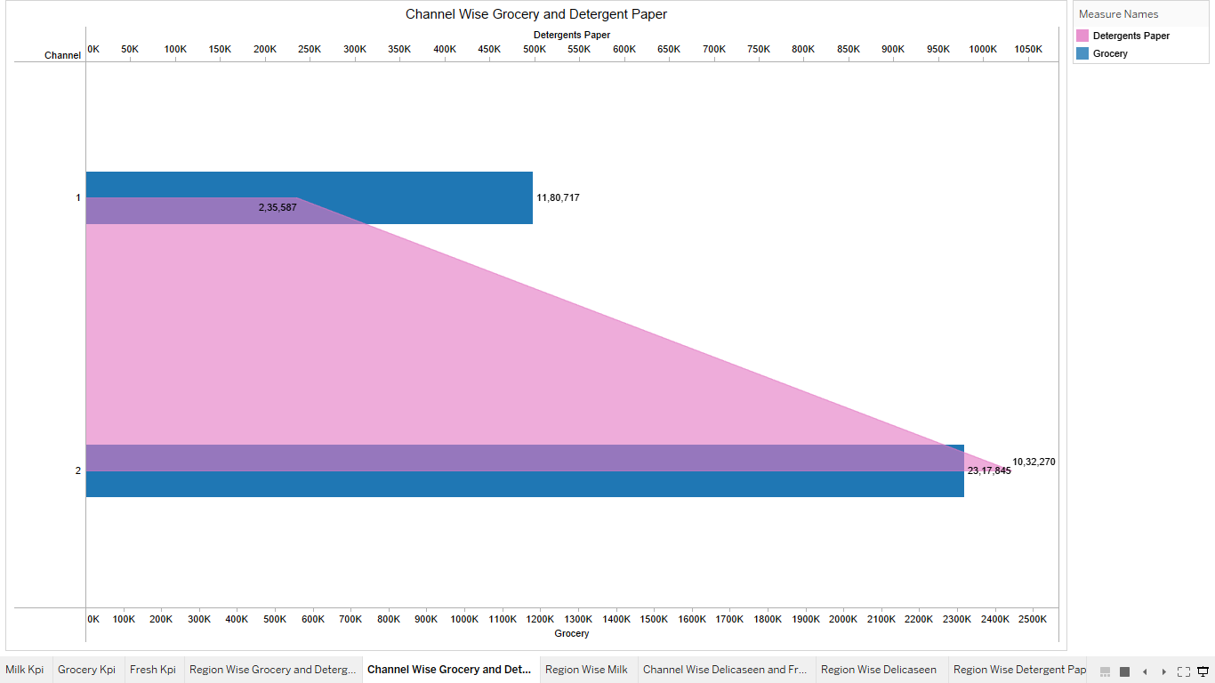

***3.6***

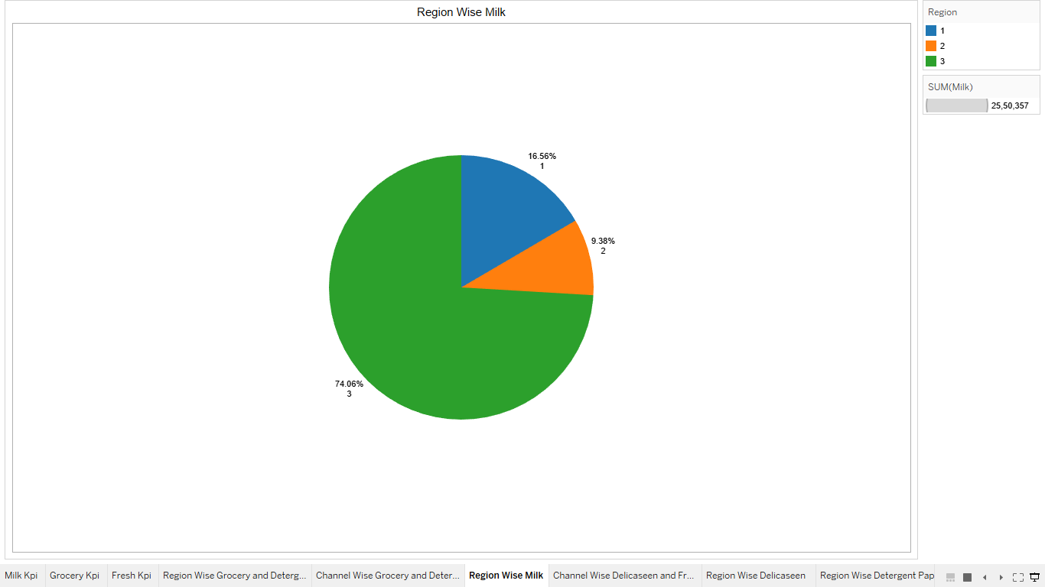

***3.7***

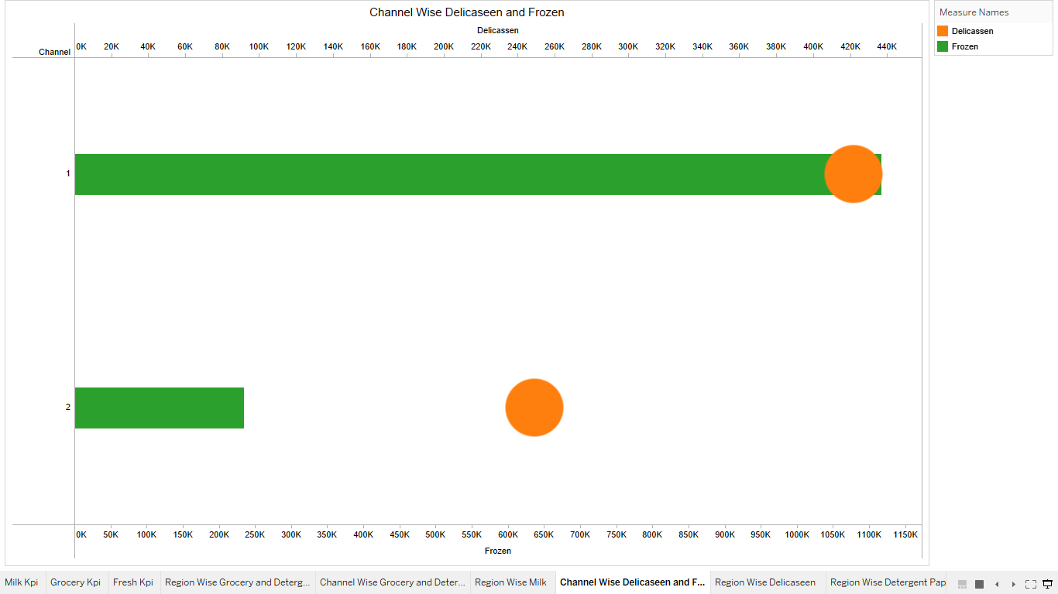

***3.8***

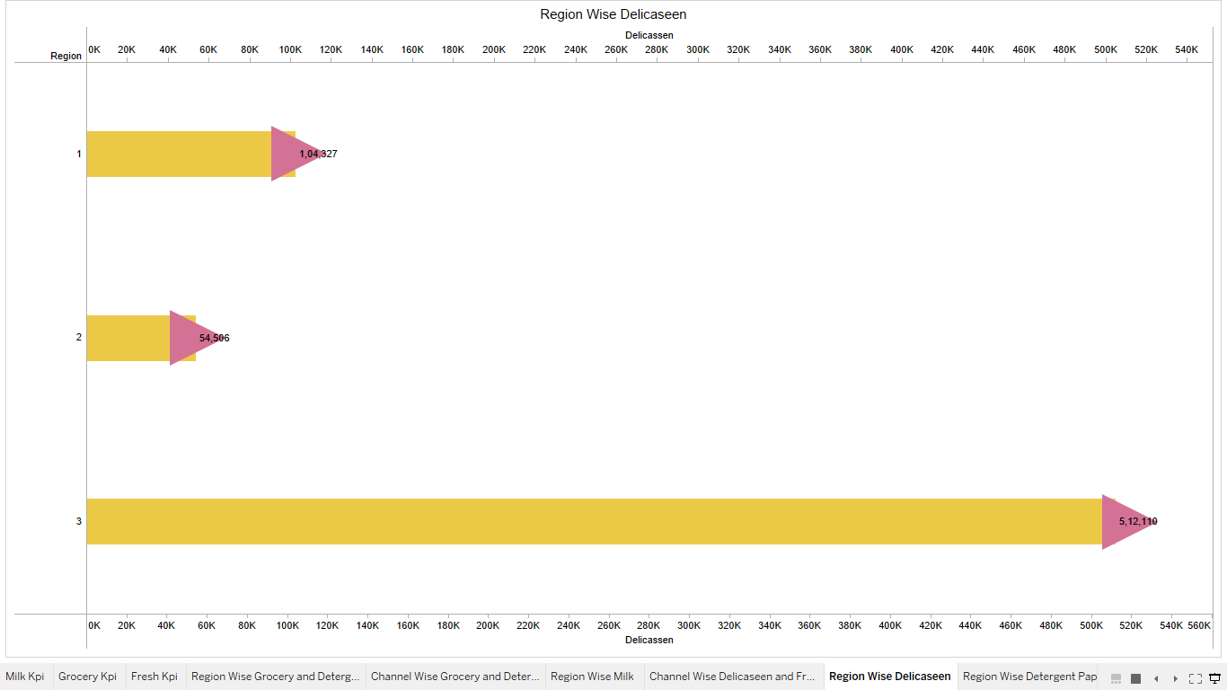

***3.9***

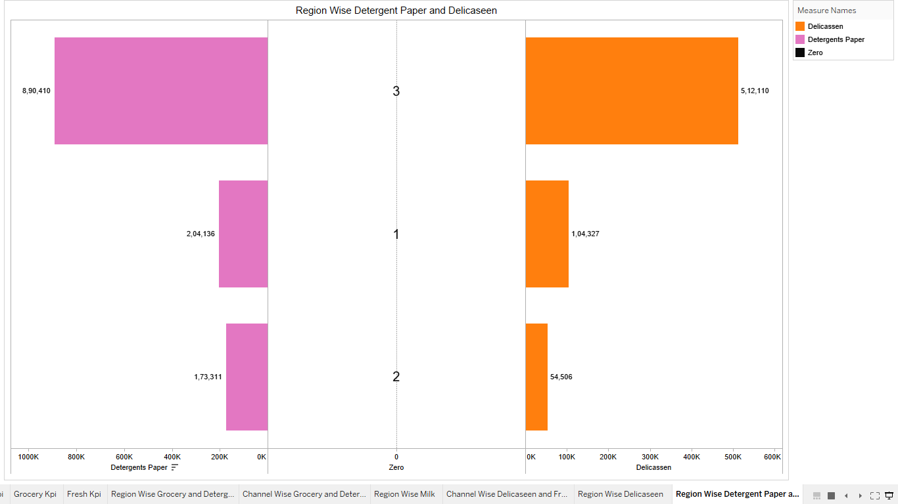

***3.10***

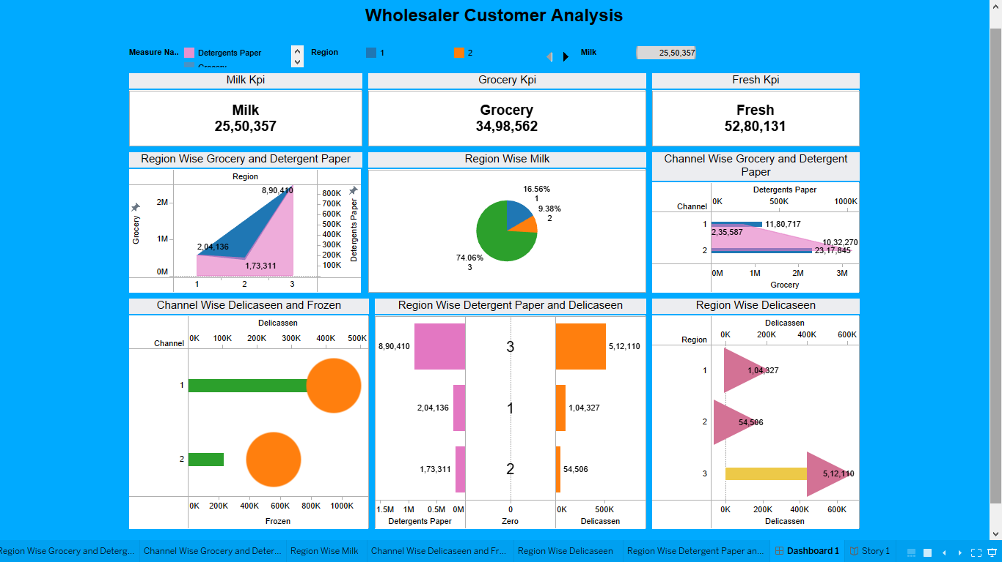

**3.11**

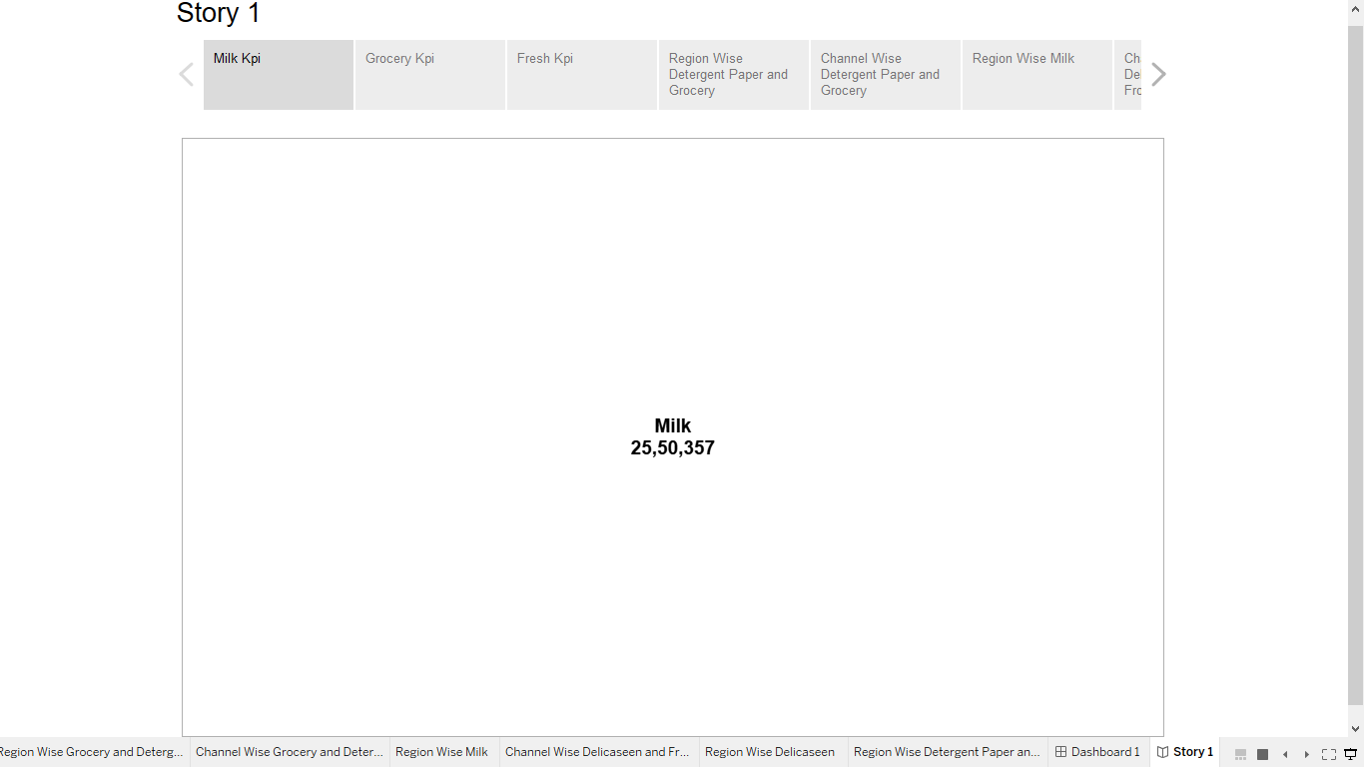

***3.12***

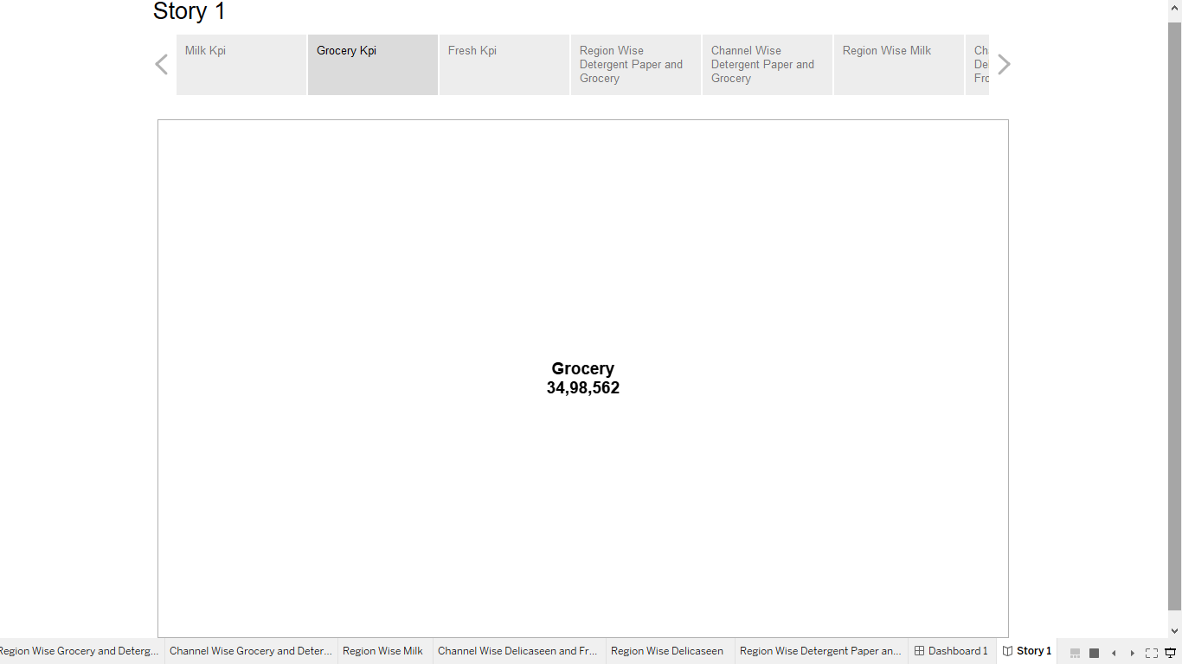

***3.13***

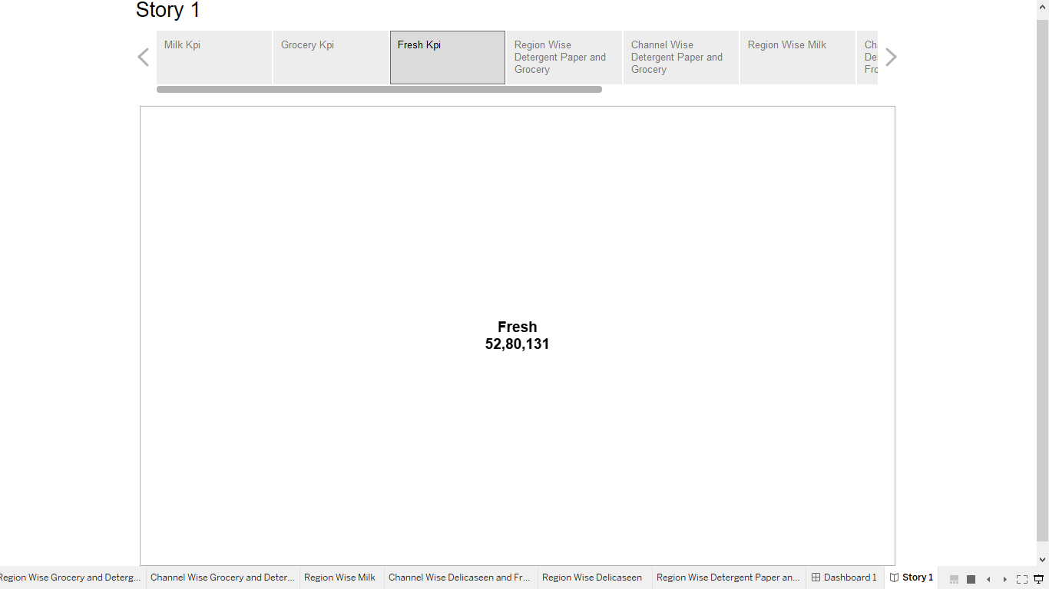

***3.14***

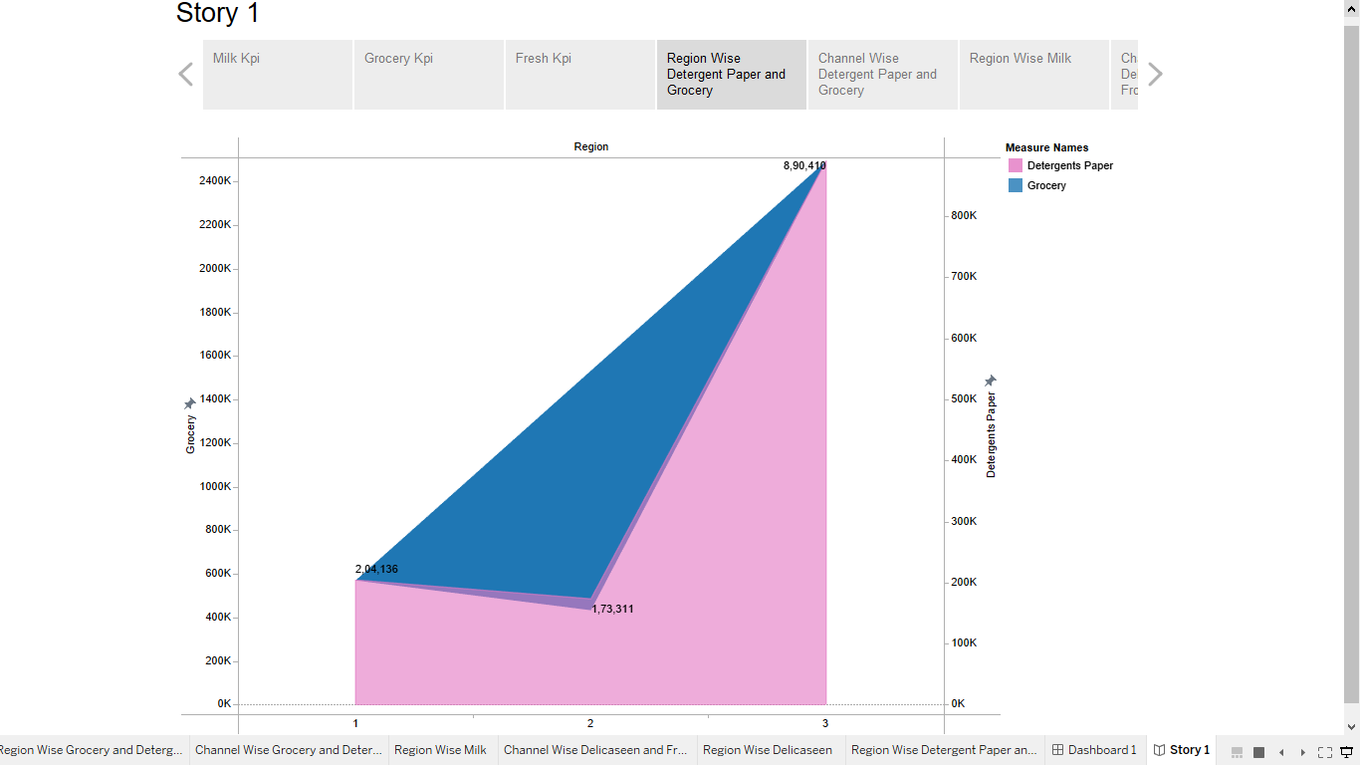

***3.15***

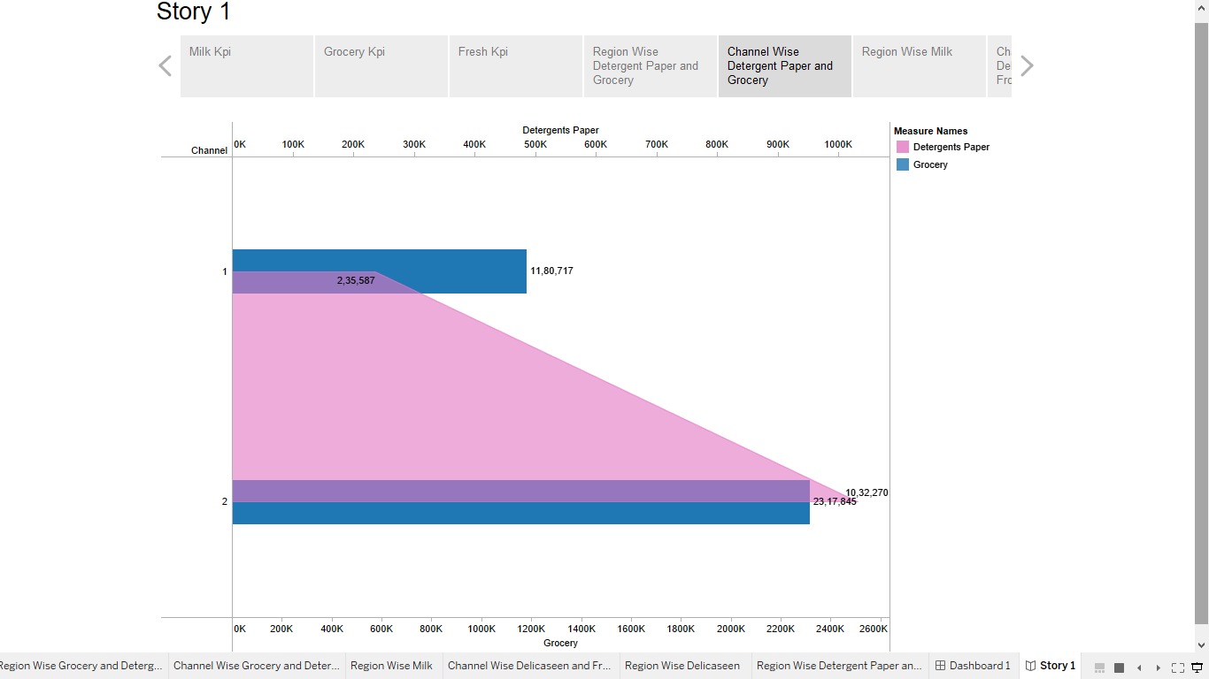

***3.16***

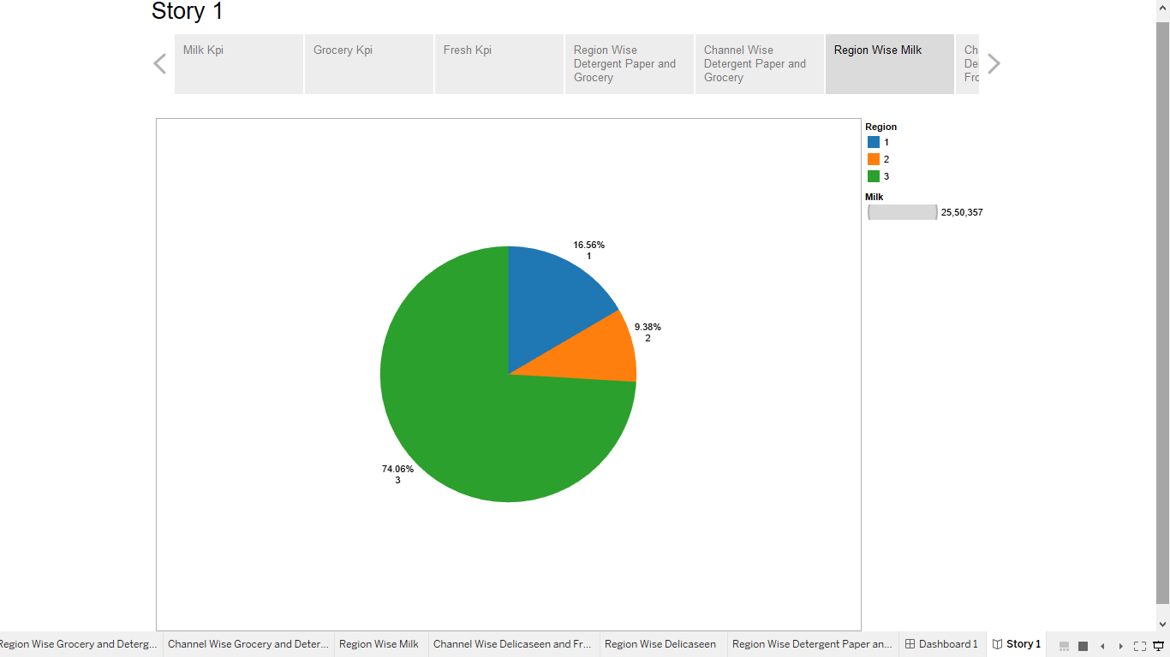

***3.17***

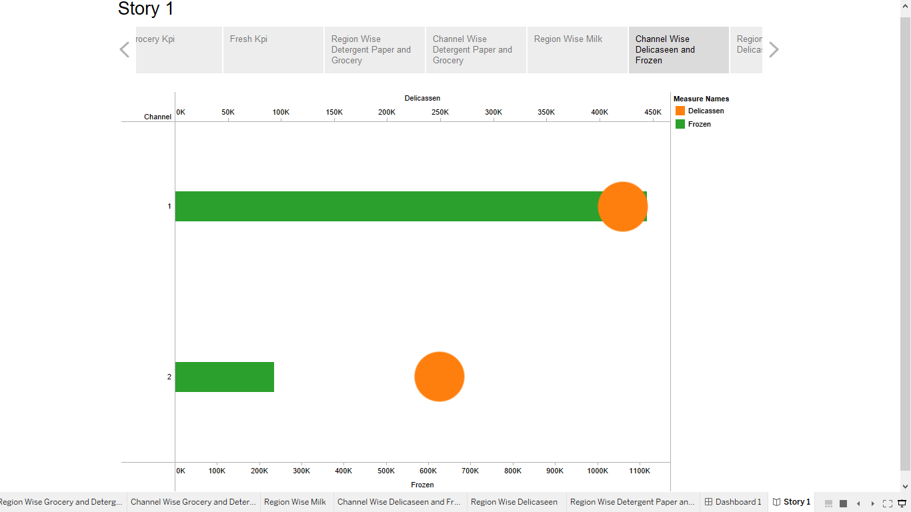

***3.18***

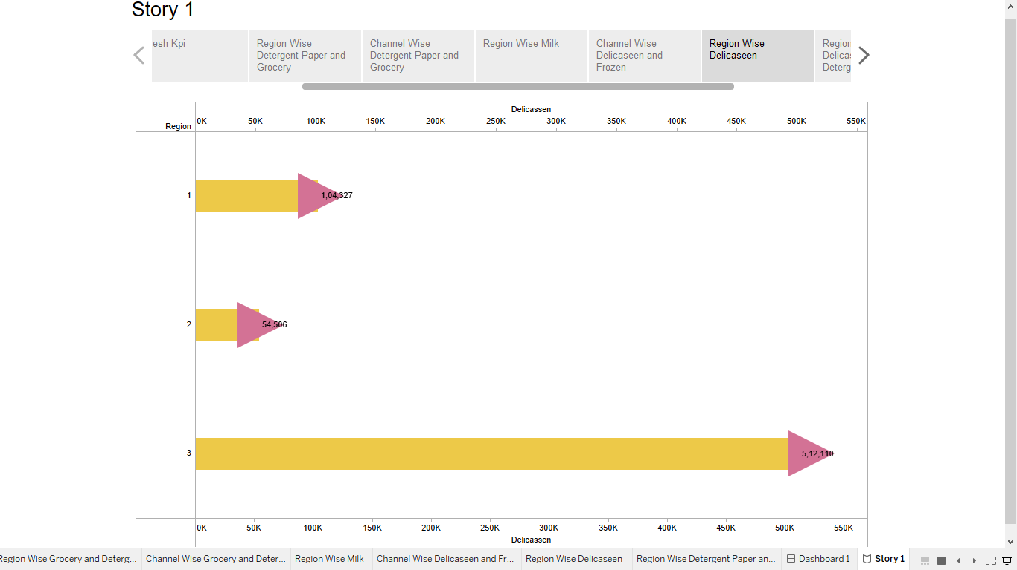

***3.19***

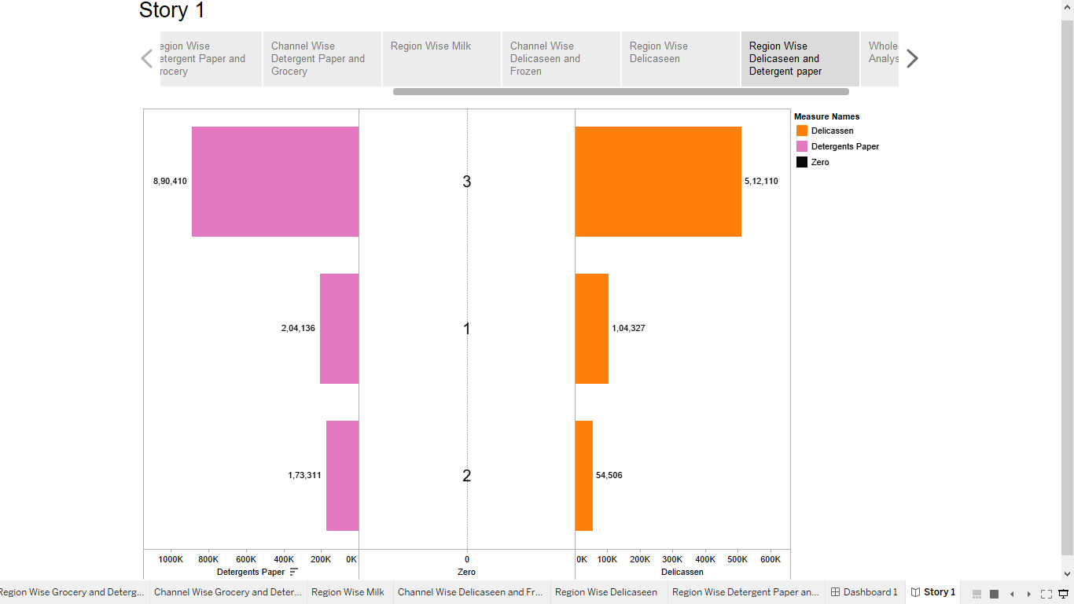

***3.20***

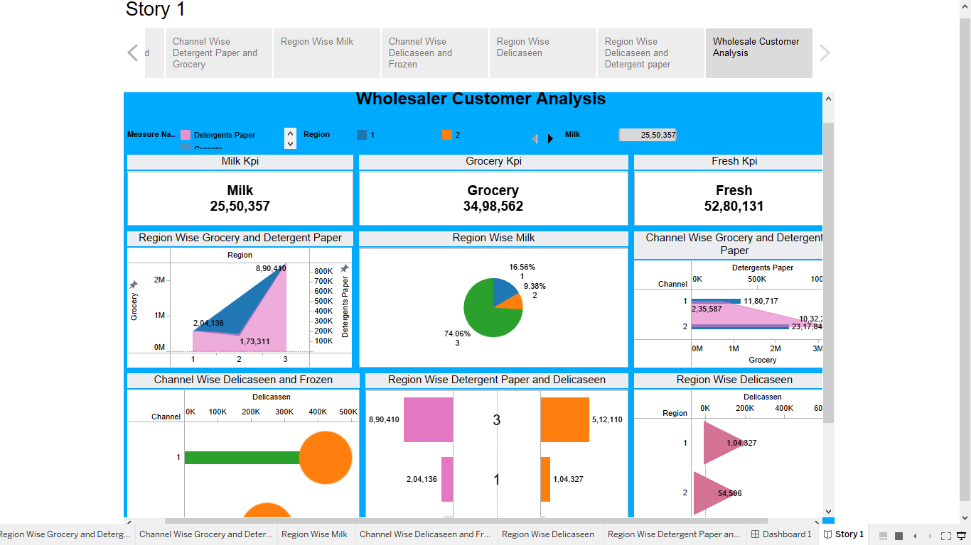

**4 . ADVANTAGES:**

* + - Manufacturers that work with wholesale distributors can invest less to expand their market, since the wholesaler is responsible for distributing the product to far-flung retailers. Manufacturers don’t need to hire, develop or maintain expensive to sell directly customers.
    - Because wholesale distribution simplifies operations for manufacturers and retailers, it can also reduce their operating costs. Retailers that buy from wholesalers may also pay lower prices than when buying small quantities directly from manufacturers.
    - Wholesalers often have extensive warehouse capacity for storing inventory, freeing manufacturers and retailers from the burden and cost of maintaining large stocks of products.

**DISADVANTAGES**:

* + - Some manufacturers are opting to sell directly to consumers, either online or via their own retail channels, both to increase their profit margins and to maintain greater control over their brand and customer experience.
    - Distributors need to meet increased customer expectations, which have been fuelled by retail ecommerce experiences: fast delivery, real-time visibility into orders and delivery status, and 24/7 customer service.

***5. APPLICATION:***

* The consumption and production of marketed food are spatially separated Production is primarily in rural areas while consumptions is mainly in urban areas.
* In today’s highly competitive business landscape, gaining deep market insights is essential for businesses to thrive and grow.

***6 .CONCULUSIONS:***

* The Spending of Hotel and Retail channel are very much different which should be more or less equal.
* The Spend should be equal for different region.
* There are inconsistencies in spending of different items, which should be minimised.

***7. FUTURE SCOPE:***

* The future scope of Marketing is increasing exponentially. It involves researching, planning, and coordinating. The growth of digital technologies and the Internet boom have positively impacted marketing scope.